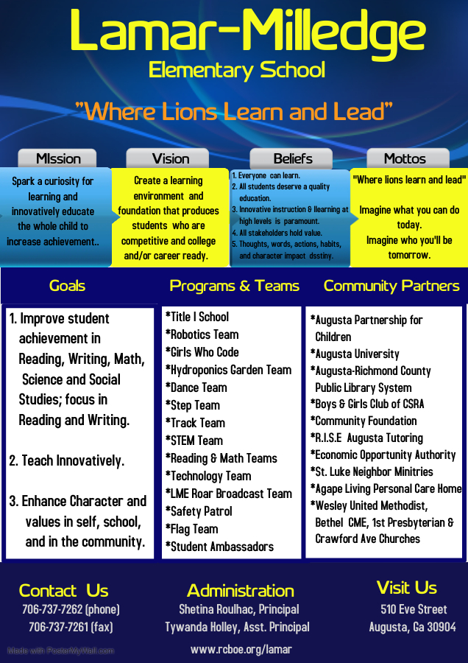

Eric Lewis, Principal

Tywanda Holley, Assistant Principal



Eric Lewis, Principal

Tywanda Holley, Assistant Principal